MULTIPLE CHOICE WHICH IS THE CORRECT MEANING FOR EACH ROAD SIGN |  | 1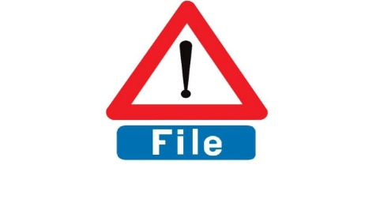  BELGIUM -Single file traffic, Single file lane, Traffic queues likely ahead, Warning dangerous section of road
2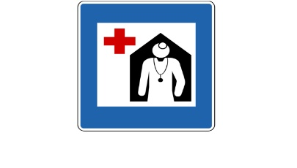  NORWAY-Church, Nunnery, Veterinary or Hospital | 3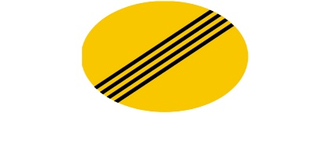  ICELAND- Skid marks ahead, End of all restrictions, No parking before 4, slippery surface | 4  ESTONIA -Bus Lane, Tram Ahead, Cable Car Above, Car Park Elevator
5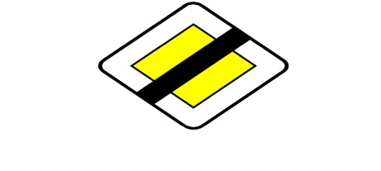  SPAIN – Do not enter yellow box section, No parking in yellow zone, Do not cross tram line, End of priority. | 6  Spain – Stop Before proceeding, Give way sign ahead, Vehicles merging, | 7  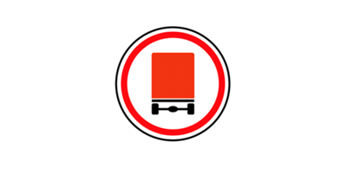  RUSSIA- No lorries allowed, Truck Stop, Vehicles carrying dangerous goods prohibited, Beware of Heavy Goods Vehicles
8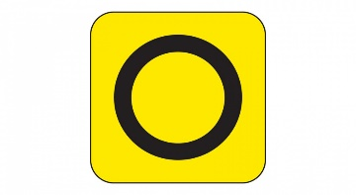  UK-Emergency diversion route, Controlled parking zone, Advanced warning of restrictions. | 9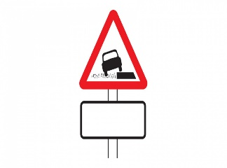  UK –No pavement parking, Uneven road ahead, Soft Verges. | 10  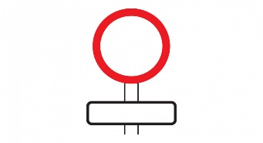  UK – No speed limit for vehicles, Tractors and HGVs only. Only bicycles being pushed

