GHOULIES AND GHOSTIES  IDENTIFY THE FULL NAMES OF THESE HORRIBLE CHARACTERS.  INSERT TWO NAMES WHERE REQUIRED, SOME HAVE BEEN FILLED IN FOR YOU. |  | 2 __________ / __________
2. ______ /_______________  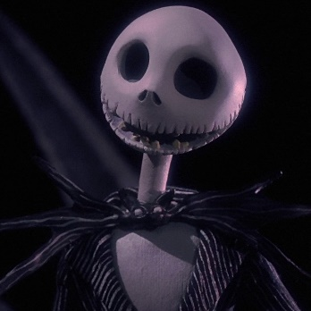 | 3. __________ VORHEES | 4. __________ / _________
5. ___ / ________________  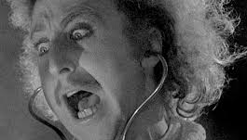 | 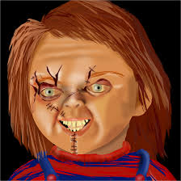  6. __________ | 7. _____ /______ /___ /____________
8. ___________ | 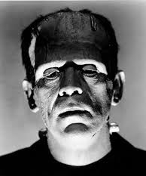  9. ______________ / __________ | 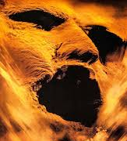  10 _____ / _________

